Alexander Howard

My Style:

* I like to get to work, and I don’t like things getting in the way of that. So if my coworkers got in the way I would work by my self and complete their jobs for them, then write them up for laziness.
* I am motivated by the prospect of learning more. Even if I was the smartest person in the world I would continue to try and learn more, as that’s one of the few things I enjoy in life.
* I hate unnecessary steps to a process, like if a boss wants to know every little thing I’m doing, and it’s slowing me down, then I will tell him off. Or meetings.
* I will only let people approach me if they have something useful to do with me, or are telling me about something useful.

What I value:

* I value productivity and proper work ethic. Those who don’t share this idea I will mostly ignore.
* I also value professionalism, because when there is goofing off, it tends to lead to a lack of stuff getting done.

What I don’t have patience for:

* Laziness, there is far too many people who do nothing with their lives, living in permanent stagnation.
* Irrationality. When there is a simple solution to a problem, and people aren’t even willing to consider it due to it being “too difficult” or “too expensive” I find that I consider them weak.

How best to communicate with me:

* Short and to the point. I would rather a conversation last 30 seconds and I get to continue with my work, than we talk for 30 minutes, and a lot of the conversation is just banter.
* If both of us don’t know the answer, then I am more than happy to figure it out. With or without others involved I don’t care.

How to help me:

* I work best alone, so the best thing to do is to leave me alone so I can just listen to my music and get work done, learning as I go if needed.

What people misunderstand about me:

* I can come off a rather cold hearted, but I just get bored very easily. So, I enjoy a constant challenge. When people are not being useful or interesting, I would rather get work done than talk to them. It’s not that I don’t like the person, it’s just I find unnecessary banter a waste of time.

Health: Having a mentally fit mind to use to solve problems, motivation, and having a physically fit body to enact those decisions. 1/2

Work: Getting a project you are working on done. Think about future prospects you could participate in. All the things you could do in the future. 3/4

Play: Enjoy your time off while still being productive. But don’t just waste time for the sake of it. 1/2

Love: A waste of time. It causes more problems than is worth it and takes time away from work. 0

Workview: Work is the thing that keeps me going. My mind is always active, and it NEEDS something to do otherwise life feels like torture. I work because I enjoy it and I feel there is no other alternative for me. Even if there was an alternative, I don’t think I would let myself out of pride and a sense of duty. Money has no place for me, just a means to an end. The entire point of working is to learn and grow. If I’m not improving, then I’m failing.

Lifeview: We are here to grow and learn. I also believe that learning is meaning of life, because without it we are stagnant. Others are simply a way to do more work faster. The different instances of country and family are unimportant rules that keep progress from happening. I don’t really care if there is a higher power or not, that won’t influence what I want to do. All emotions are just pathways to express free will and what we hope to achieve in the form of a high life form such as artificial intelligence.

Good Time Journal:

* Casual Exercise Mid/Pos
* Fixing Coding Problems High/Pos
* Cooking Mid to High/Pos
* Running High/Pos
* Talking with Family Mid/Pos
* Studying Scripture Low/Neg
* Shopping mid/avg
* Planning High/Pos
* Sleeping Low/Pos
* Class Time Mid to High/Pos

Mind Maps:

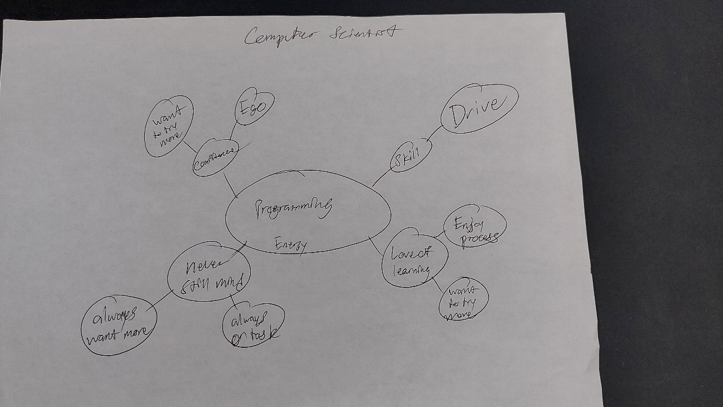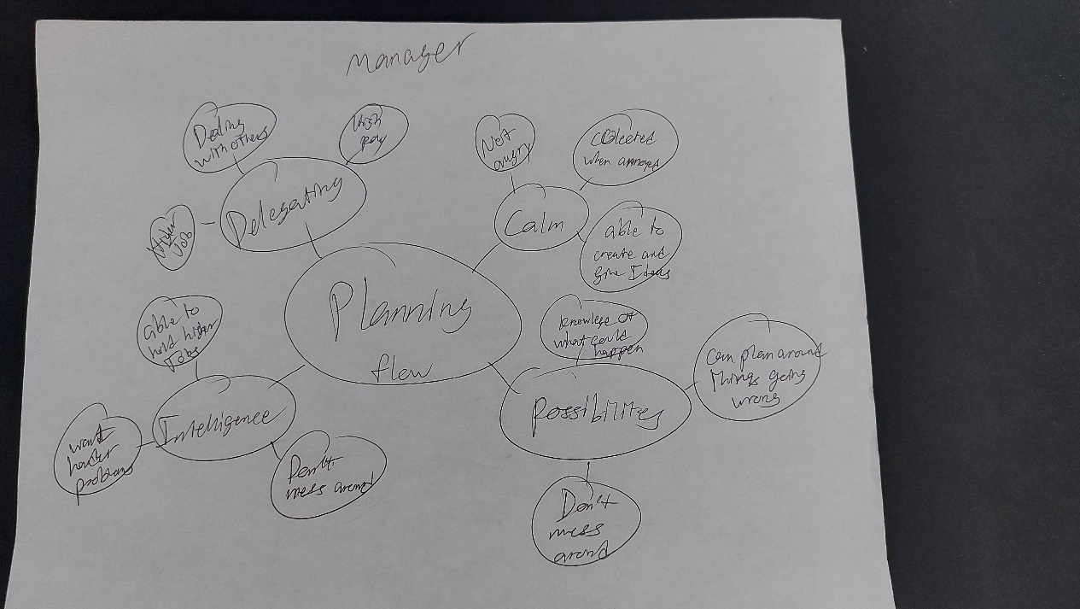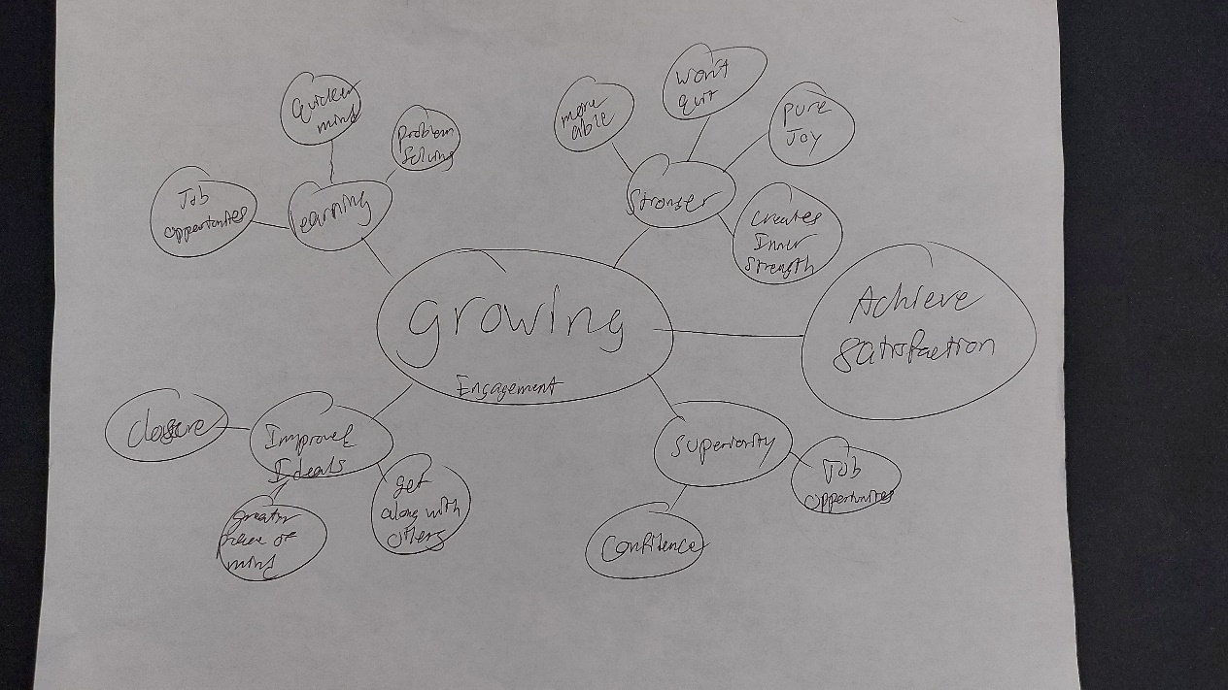

Odyssey Plans:

